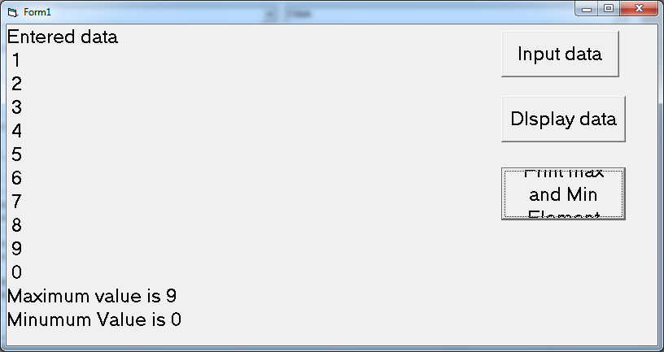

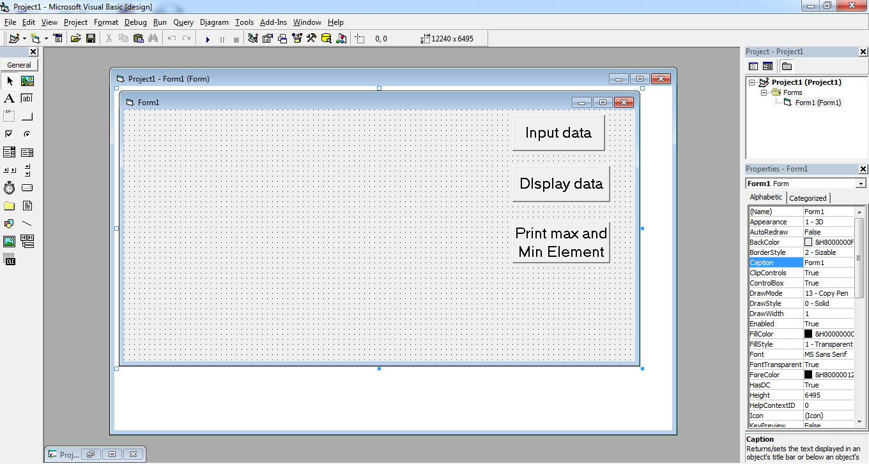

Dim num(10) As Integer

Dim num(10) As Integer

Dim i As Integer

Private Sub cmdDisplayData_Click(Index As Integer)

Print "Entered data"

For i = 1 To 10

Print num(i)

Next

End Sub

Private Sub cmdInputData_Click(Index As Integer)

For i = 1 To 10

num(i) = InputBox("Entered number")

Next

End Sub

Private Sub cmdMaxMin_Click()

Dim max As Integer, min As Integer

max = num(1)

min = num(1)

For i = 2 To 10

If num(i) > max Then max = num(i)

If num(i) < min Then min = num(i)

**Output for Area of Circle:**

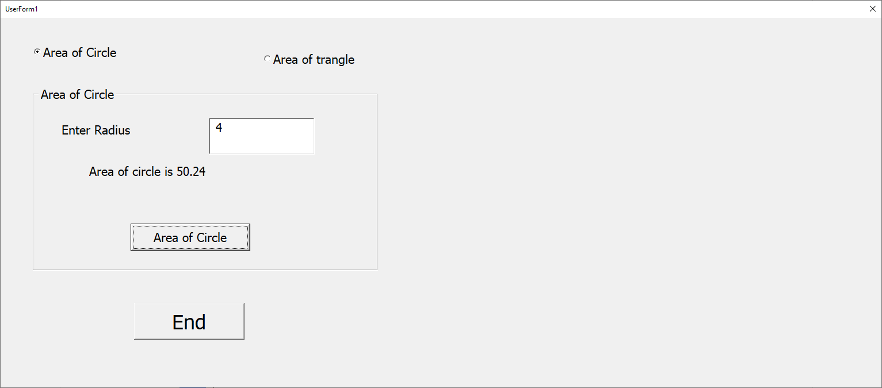

**Output for area of Trangle:**

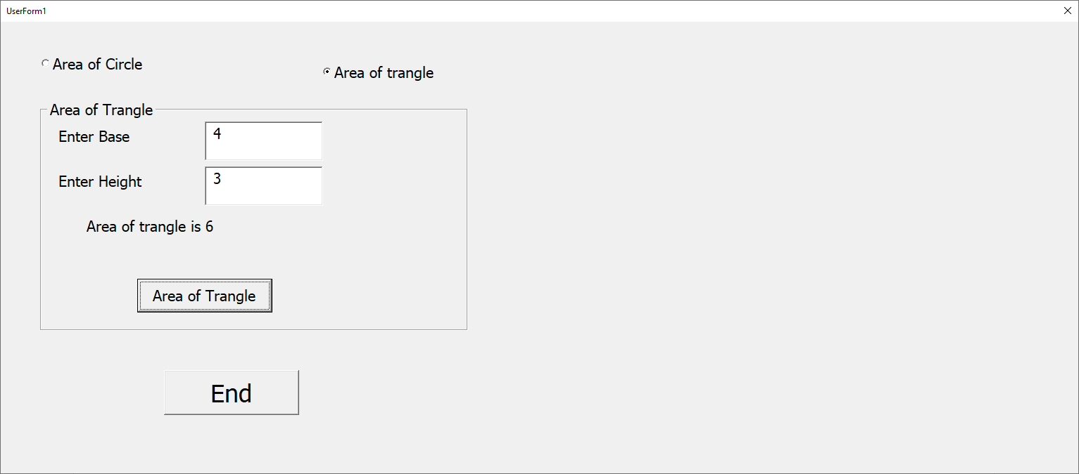

Next

Print "Maximum value is " & max

Print "Minumum Value is " & min

End Sub

Private Sub cmdLinerarSearch_Click()

Dim flag As Boolean

Dim search As Integer

flag = False

search = InputBox("Enter element to be searched")

For i = 1 To 10

If num(i) = search Then

flag = True

Exit For

End If

Next

If flag = True Then

Print search & " Found"

Else

Dim i As Integer

Private Sub cmdDisplayData_Click(Index As Integer)

Print "Entered data"

For i = 1 To 10

Print num(i)

Next

End Sub

Private Sub cmdInputData_Click(Index As Integer)

For i = 1 To 10

num(i) = InputBox("Entered number")

Next

End Sub

Private Sub cmdMaxMin_Click()

Dim max As Integer, min As Integer

max = num(1)

min = num(1)

For i = 2 To 10

If num(i) > max Then max = num(i)

If num(i) < min Then min = num(i)

Next

Print "Maximum value is " & max

Print "Minumum Value is " & min

End Sub

Print search & " is not found"

End If

